For the safety of everyone IN and travelling THROUGH Rush Township, street visibility is vital, and our roads need to be clear of overhanging and overgrown trees and bushes. As a property owner and/or property tenant, you need to be conscious about managing vegetation on your property to ensure it does not block visibility of roadways. Therefore, homeowners MUST cut back, groom, and maintain all of their trees and brush near the road that may be a hazard or danger in obscuring the line of sight for traffic.

If a sight distance problem is evident on your property and the homeowners do not rectify these issues, the Township may initiate enforcement action or the Township WILL take action and lop the overgrowth, therefore eliminating the hazards.

TRAFFIC-OBSCURING OVERGROWTH

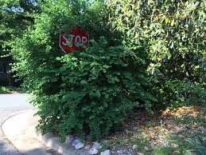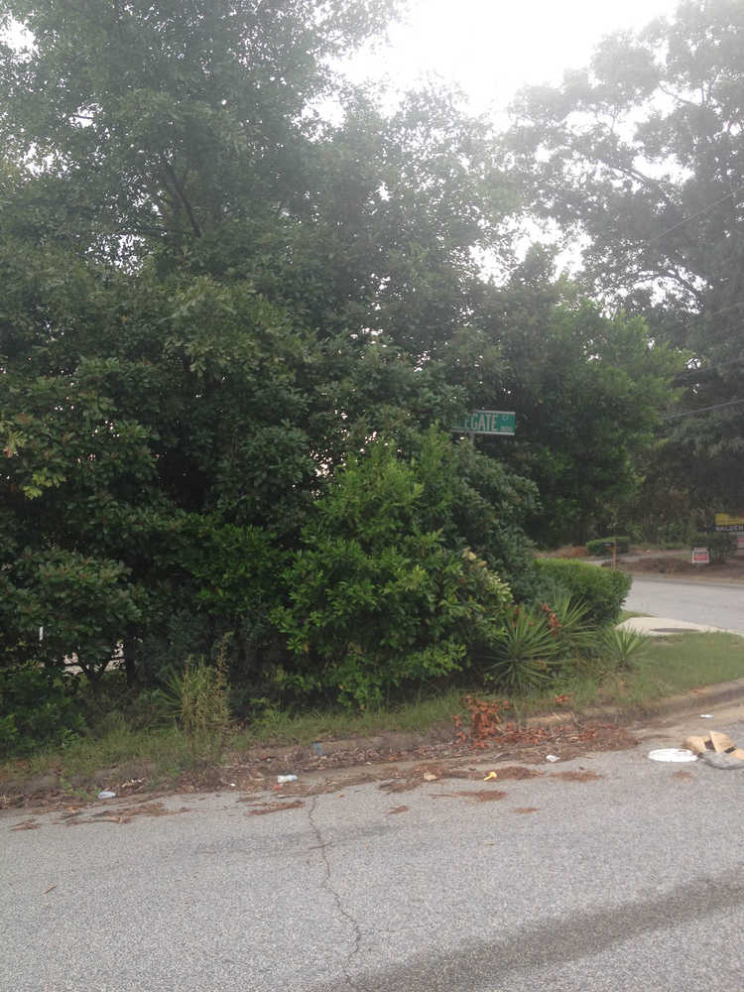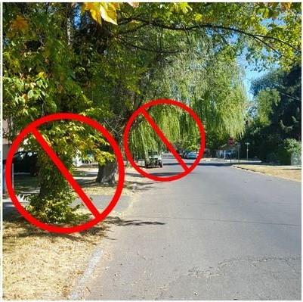

MAINTAINED OVERGROWTH

